**FX SHOP**

**Importing New Records**

The import scripts are attached to the buttons on the home screen.

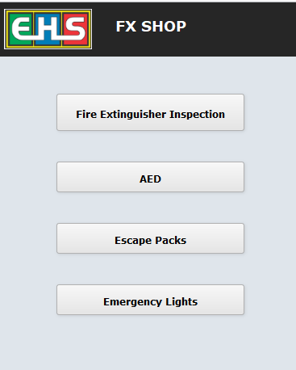

Records will be imported automatically on the click of a button at the beginning of every month as the devices are inspected monthly. All the records from last month will be duplicated and made ready for inspection for the current month.

Creating thousands of records is time consuming and the process should not be interrupted once it is initiated. Hence, the first time login of the month would perform imports and the following are approximate time estimates for the importing activity:

Fire Extinguishers: 15- 18 minutes

AED: 6 – 8 minutes

Escape Packs: 2-4 minutes

Emergency Lights: 17- 20 minutes

Subsequent logins for the month will be done quickly.

**FIRE EXTINGUISHERS:**

**Inspections:**

EHS Staff and the Vendor will see their respective list of buildings to be inspected according to the monthly schedule. The ‘Building Name’ text appears in Green color once all the devices in the building are inspected.

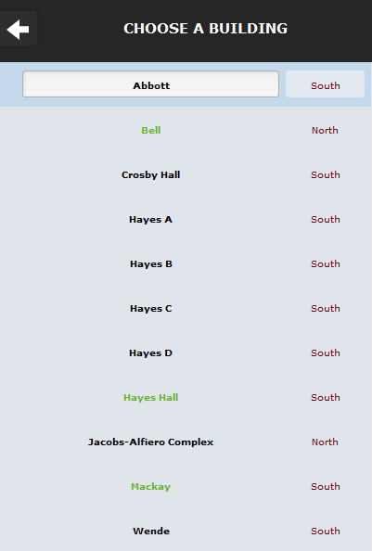

Clicking on the Building, displays a list of all devices in the building to be inspected for the current month. However, a device will not be listed by default if:

* It is already inspected for the current month.
* The device needs to be maintained (i.e. Next Hydro Test is scheduled for the current year)

If you wish to see all devices including the above, then click the “Show All in Current Building” button on the top-right.

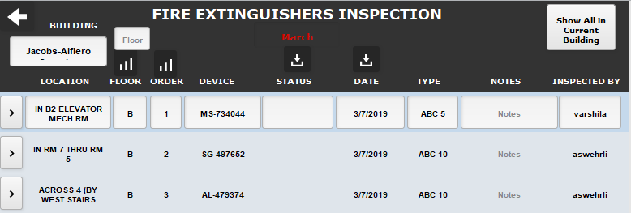

**Maintenance:**

Fire Extinguishers with ‘Next Hydro Test’ in the current year (“Tested Till” field) need to be maintained. Similar to inspections, buildings are maintained according to the schedule by the EHS Staff.

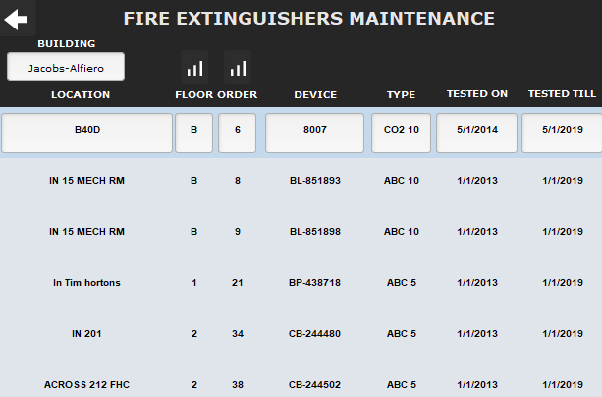

**Failed Devices:**

Displays the list of Devices in all buildings whose “Status” field is set to “FAIL”.

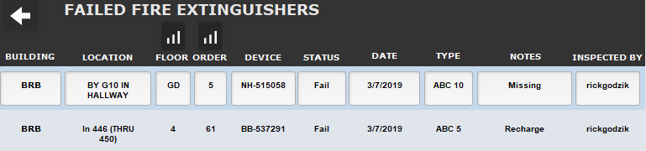

**Out of Order Devices:**

Displays the list of Devices in all buildings whose “Status” field is set to “Out of Order”.

**All Buildings:**

Displays the list of all Devices inspected/to be inspected for the current month.

**Reports:**

Allows the EHS Staff to create inspection reports for current or last month for the building of interest. Reports can be saved as PDF and emailed by following the instructions in the prompts after clicking the “Send Email” button.

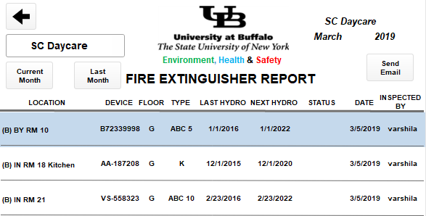

**Count:**

The “Count” field on the home screen calculates the number of devices inspected by the Vendor for the current month (Example: 462 in the screenshot below). A devices will be counted only if it is “Inspected By” the vendor (rickgodzik) and the “Status” field is set to Pass, Fail or Missing.

The script to calculate the Count is present in the script named “Import For Every Month&Year”.

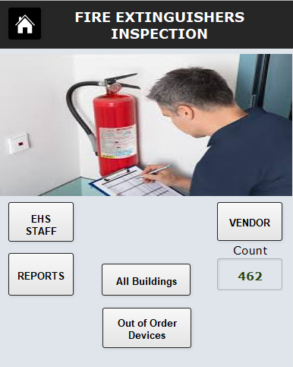

**AED**

**Assign:**

AED’s are inspected every month. Buildings can be assigned to EHS Staff on a monthly basis.

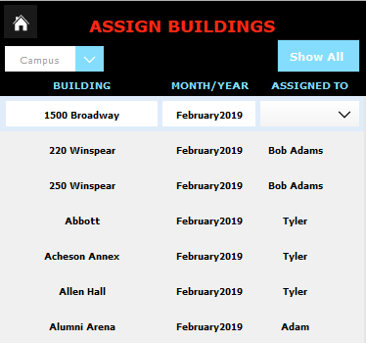

**Inspect:**

Buildings can be filtered based on whom it is assigned to. AEDs in each building are ready for inspection.

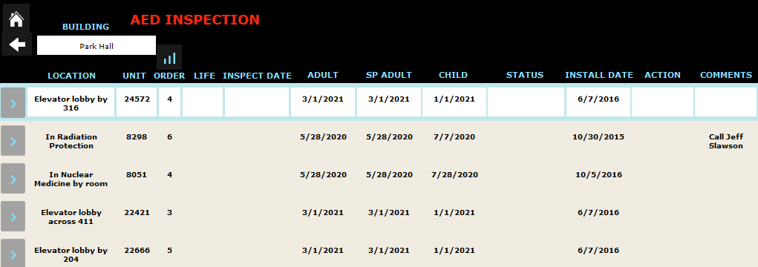

**ESCAPE PACKS:**

**Inspect:**

Escape Packs are inspected every month. Just select the building and all the devices in that particular building will be listed.

**EMERGENCY LIGHTS:**

**Inspect:**

Emergency Lights are inspected every month. Pick a building for inspection and all the devices in that particular building will be listed.

**Reports:**

Allows the EHS Staff to create inspection reports for current or last month for the building of interest. Reports can be saved as PDF and emailed by following the instructions in the prompts after clicking the “Send Email” button.

